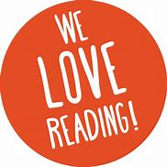

Summer Recommended

Reads

We have selected a range of books, that pupils may wish to read during the summer holiday.

**Earth Class**

**Water Class Year 1**

**Water Class Year 2**

**

**‘If you don’t like to read, you haven’t found the right book. ’**

***J.K Rowling***

Mystery books, adventure stories, myths and legends, biographies, graphic novels, funny stories and fantasy reading, there should be a genre for everyone.

**Air Class Year 4**

**Fire Class Year 6**

**Fire Class Year 5**

